### GEOGRAPHIC INFORMATION SYSTEM FOR FLOOD RISK

**ASSESSMENT AND MANAGEMENT IN PALUAN, OCCIDENTAL MINDORO**

AN UNDERGRADUATE RESEARCH PROJECT

Presented to the Faculty of College of Arts, Sciences, and Technology

**OCCIDENTAL MINDORO STATE COLLEGE**

Mamburao Campus

In Partial Fulfillment of the Requirements for the Degree

**BACHELOR OF SCIENCE IN INFORMATION TECHNOLOGY**

**TYRONE C. PALABAY**

### MARK DAVEN H. MARIÑO

### LEE V. DUPAGAN

**JOHN LLOYD M. BRIZUELA**

**CHYRISH C. CORNELIA**

**CRISTELLE MAE C. LACUESTA**

December 2024

**CHAPTER 1**

**BACKGROUND OF THE STUDY**

### Introduction

A Geographic Information System (GIS) is a powerful tool that combines computer software, hardware, data, and skilled personnel to manage and analyze information linked to specific locations on the earth's surface. GIS-based exemplifies the power of integrating spatial analysis with information, offering a dynamic and geographically nuanced approach to data management that goes beyond traditional data analysis methods (Fletcher-Lartey & Caprarelli, 2016). This system allows for the entry, manipulation, analysis, and presentation of spatial data, which includes addresses, coordinates, and even complex three-dimensional geometries (Ali, 2020). Geographic Information System (GIS) is an effective decision-making tool in the domains of physical, social, and economic space. GIS tools enable the acquisition of spatial data from a variety of sources, rapid data processing, and the release of data in the desired format for multidisciplinary analyses, studies, and forecasts (Kurowska et al., 2020). A number of studies have been carried out related to various problems that can be solved through the application of GIS, including mapping, analyzing, storing, and presenting data (Ma et al., 2019). A number of previous studies have developed and applied Geographic Information Systems (GIS) for various purposes to assist decision-making. Research related to the movement and distribution of humans using geographic information systems (GIS) is increasingly getting the attention of experts today. Moreover, In Paluan in Occidental Mindoro faced a significant challenge with disaster management during typhoons the Municipal Disaster Risk Reduction and Management Office (MDRRMO) struggled to analyze crucial household details such as the number of residents, persons with disabilities (PWDs), indigenous peoples (IPs), pregnant individuals, and other relevant demographics. This essential location-based information, known in the GIS industry as spatial data, was critical for effective disaster response. To address this problem, the researcher proposed a Flood Risk Assessment and Management in Paluan Occidental Mindoro with Geographic Information System.

In Paluan GIS will help various parties in making decisions regarding the trend of the distribution of humans and various other objects. GIS has become one of the most important data sources in assisting the development and understanding of the distribution of the current human population, and GIS also provides an opportunity for policymakers to access population data based on online maps (Chow et al., 2018; Mulvey & Curtis, 2018). Moreover, GIS combines map elements (geographical) and information about the map (attribute data) designed to obtain, process, manipulate, analyze, demonstrate and display spatial data to complete planning, processing, and researching problems. The term "geographic information system" was first used in the 1960s to refer to a computerized system to help answer questions related to maps that show land use in Canada (Kumar et al., 2023). Moreover, there are two kinds of data processed in GIS, namely geospatial data (spatial data and non-spatial data). Spatial data is data related to geographical conditions such as rivers, administrative areas, buildings, roads, etc. Spatial data is obtained from maps, aerial photographs, satellite images, statistical data, etc. In general, human perception regarding the form of representation of spatial entities is the concept of raster and vector. Meanwhile, non-spatial data is in addition to spatial data, namely data in the form of text or numbers, which is usually referred to as attributes. This non-spatial data will explain the spatial data or as a basis for describing the spatial data. Additionally, it frequently recurs and typhoons, storm surges, floods, and landslides are becoming more intense due to the growing effects of global warming. Public Law 10121, commonly referred to as the under the 2010 Philippine Disaster Risk Reduction and Management Act, all government organizations at all levels, from the federal to the municipal, to institutionalize integrated and comprehensive procedure for developing policies, organizing, and carrying out actions meant to minimizing the effects, strengthening the talents, and lowering the vulnerabilities of dangers (salcedoeasternsamar.gov.ph) At this most demanding present time, the municipal government is committed to pursue prospective disaster risk reduction and management activities that will address and seek to avoid the development of new or increased disaster risks through the formulation of the Municipal Disaster Risk Reduction and Management (MDRRM). The problem is that community lacked detailed accurate data crucial for effective disaster response. The Local Disaster Risk Reduction and Management (LDRRM) Plan is the platform of every local government unit in the fast delivery of services concerning disasters. An effective LDRRM Plan does not only focuses on its interventions to natural disasters but also to man-made disasters such as roadside accidents, vehicular accidents and fire. It should also include the programs, projects and activities that have emphasis on the Disaster Prevention and Mitigation, Preparedness, Response and Rehabilitation and Recovery (salcedoeasternsamar.gov.ph) Paluan is a 3rd class coastal municipality of Occidental Mindoro Province in MIMAROPA Region or Region 4-B, Philippines.

The researcher aims to develop a system entitled Geographic Information System for Flood Risk Assessment and Management In Paluan, Occidental Mindoro. This system will enhance the safety of residents by providing detailed and accurate spatial data. Different GIS systems often use different icons for the same features, and data layers can be inconsistent, making it crucial for users to carefully select and verify the data layers they need. A study will focus on Paluan with web GIS, which offers a dynamic and interactive map compared to traditional static maps. This GIS map visually represents quantifiable data, revealing previously unseen features by highlighting them and showing changes over time based on the given attributes. This innovative approach aims to improve disaster preparedness and response in Paluan, ensuring the safety and well-being of its residents.

### Objectives of the Study

This study aims to develop a household disaster geographic information management system with geo-tagging in Paluan, Occidental Mindoro.

1. To design a GIS flood risk assessment and management with the

following features;

1. To provide a map using Google Maps API
2. To deliver a reliable and interactive mapping service.
3. To design a GUI and provide a user-friendly system
4. To provide user management: to provide features handling user accounts, permissions, and roles efficiently.
5. To provide data analysis and visualization;
6. To provide geo-tagging on adding household records;
7. To provide navigation tools.
8. To generate reports;
9. To provide backup data using import/export.
10. To develop household disaster geographic information management system with geo-tagging with the use of following software:
11. TypeScript, Tailwind CSS, and NextJS;
12. Firebase Database;
13. Node and NPM;
14. To test and improve the system.
15. To test and assess the system's performance in accordance with ISO 25010 using the following criteria: functionality, performance efficiency, content, , usability, and security,
16. To provide a user's manual.

**Significance of the Study**

The following are the beneficiaries of the system:

**Municipality of Paluan.** Effective MDRRMO staff should have strong technical skills and a deep understanding of disaster risk reduction and management principles and practices. Staff should also be able to communicate effectively with a wide range of stakeholders, including local government officials, community leaders, and emergency responders. Additionally, MDRRMO staff should be able to work well in a team environment, have strong problem-solving skills, and be able to handle high-pressure situations during emergencies and disasters.

**Municipal Disaster Risk Reduction and Management Office.** The Municipal Disaster Risk Reduction and Management Office (MDRRMO) is responsible for the development, implementation, and coordination of disaster risk reduction and management (DRRM) programs and activities at the local level. The MDRRMO is typically headed by a Municipal Disaster Risk Reduction and Management Officer (MDRRMO) who is appointed by the municipal mayor.

**Future Researchers.** This research may come from various fields, such as geography, environmental science, engineering, public policy, and social sciences, and may have expertise in areas such as hazard and risk assessment, vulnerability analysis, early warning systems, community-based disaster management, climate change impacts and adaptation strategies, and monitoring and evaluation of DRRM and CCA programs and projects.

### Conceptual Framework of the Study

The input requirements, processes, and output are shown in Fig. 1. Knowledge, Software, and Hardware Requirements are the key features that will help the researchers to develop the software. For input, the proponents will need to study the following topics: Index-based flood risk assessment, River Flood Hazard Modeling, Reduction Planning, Geo-Tagging in PMAYG, Flood Risk Management, Rural housing, Web Mapping; Eras, Trends and Directions and last is ISO 25010. For the software, the researchers will use Typescript, tailwind, CSS, Firebase and Node JS for structuring the system. In terms of hardware, laptop and desktop computer and mobile phone will be needed. In the process, the researchers will use the agile development life cycle model which includes planning, designing, developing, testing, deployment, reviewing, and launching. These processes will be the guide of the proponents in developing the Geographic Information System for Flood Risk Assessment and Management in Paluan, Occidental Mindoro.

Fig. 1. The research paradigm of the study.

**Process**

**Input**

**Output**

**Agile model:**

1. Planning
2. Designing
3. Develop
4. Testing
5. Deployment
6. Review
7. Launch
8. **Knowledge Requirements**

* GIS
* GIS Flood Assessment
* GIS Flood Management
* Flood Risk Management System
* Flood risk Management
* GIS-Web Based
* Google-API
* Database Managemenr
* ISO 25010

**II.Software Requirements**

● TypeScript, tailwind CSS

● Firebase

● Node JS

**III. Hardware** Requirements

● Laptop and Computer

● Mobile Phone

* Printer

**Geographic Information System for Flood Risk Assessment and Management In Paluan, Occidental Mindoro**

### Scope and Limitations of the Study

### Floods are a recurring threat to many communities, and Paluan in Occidental Mindoro is no exception. The devastating impact of floods on lives, property, and the local economy underscores the urgent need for effective flood risk assessment and management. Geographic Information Systems (GIS) play a pivotal role in addressing these challenges, offering a blend of technology and human insight that is crucial for developing resilient communities. In the unfortunate event of a flood, GIS becomes an invaluable tool for emergency response teams. Real-time GIS data helps in monitoring the progress of floodwaters, identifying the hardest-hit areas, and deploying resources efficiently. It enables a coordinated response that can minimize damage and speed up recovery efforts. Additionally, GIS facilitates communication among various stakeholders, including government agencies, NGOs, and the local community, ensuring a unified and effective response. Moreover, administrators are responsible for validating and summarizing records in various reports to ensure monitoring of data accurately maintained and reflected in the system, However, the system is limited with redundancy of the data. The interface in mobile phone will be different compare in computer.

### Operational Definition of Terms

For better clarification and understanding of the terms used in this study, the following terms are defined conceptually.

**Agile Model.** It is used to manage the project, with a focus on development and collaboration. It helps in adapting to changes quickly and efficiently, ensuring that only necessary activities are carried out, saving time and resources.

**Node JS.** Itis a JavaScript runtime built on Chrome's V8 JavaScript engine that allows developers to run JavaScript on the server side.

**Tailwind CSS.** Itis a utility-first CSS framework that provides a set of low-level, customizable utility classes to build responsive, modern web interfaces without writing custom CSS.

**Database**. It serves as the central repository for storing structured data, such as resident information and transaction records. It ensures data integrity and enables efficient data retrieval and management for the system.

**Geo-tagging**. It is applied to associate specific geographic coordinates with various data points in the system. It can be used to track the location of events or assets, providing spatial context to the data.

**Geographic Information System (GIS).** Itis a framework used to capture, store, analyze, and visualize geographic data, create detailed maps, and perform spatial analysis, enhancing decision-making processes.

**ISO 25010 Criteria.** This set of standards is referenced in the study to assess the quality of the software product. It covers various aspects such as functionality, reliability, usability, and security, ensuring that the system meets high-quality standards.

**Node.** It is a free, open-source, cross-platform JavaScript runtime environment that lets developers create servers, web apps, command line tools and scripts.

**NPM.** It isNode package manager (npm) is a package manager and a software register but it's also a place where developers can find, build and manage code packages.

**TypeScript.** Itis a statically typed superset of JavaScript that adds optional type checking and advanced features like interfaces and enums, allowing for safer and more scalable code development.

**Firebase.** Itis a comprehensive platform developed by Google that provides a suite of cloud-based tools and services for building, managing, and scaling web and mobile applications.

**Record management system**. Handle the records of an organization efficiently. This system will manage the life cycle of records from creation to destruction, ensuring compliance with regulatory requirements and facilitating easy access to information.

**Web Application**. It’s accessible through a web browser over the internet using HTTP. Users can interact with it live without needing to install additional software on their devices.

**CHAPTER II**

**REVIEW OF RELATED LITERATURE AND STUDIES**

This chapter presents a review of related literature used in the studies to provide significant information to give a better understanding of the problem cited in this study.

### Geographic Information System (GIS)

The GIS tool plays a vital component of flood risk assessment due to the evaluation process that needs spatial information. The practice of a standard approach for evaluation and merging distinctive data affect the precision and comparability of assessment outcomes. Some nations have established national guidelines to assess flood risk potential. In addition, GIS can be utilized to study international, regional, and local flood risks and guide the implementation of a risk mitigation plan. GIS in the Philippines is a primary distinctive tool used in countrywide flood risk modeling (Gacu, 2022). However, existing high-resolution flood risk models have come to be very important. These tools can be used for flood readiness by improving these maps’ data levels. ArcGIS, developed by ESRI, is a GIS-based tool that can produce standard Web Services and make numerous network GIS uses (Gacu, 2022).

Systems for managing geographical data are called Geographic Information Systems (GIS). The corresponding geographic features are linked to these data. These digital systems are capable of integrating, storing, modifying, analyzing, and organizing data with a geographic reference (Fradelos et al.,2014). They can be broadly characterized as smart maps that provide their users with a virtual representation of the real environment. Additionally, they are capable of creating interactive geographic or descriptive inquiries, analyzing spatial data, adapting and adopting them in digital or analog media (records of spatial data, interactive maps on the Internet), and printing maps and diagrams. According to Farnia (2017), GIS technology is capable of providing the intra- and inter-logical connection between health, social services, and natural environment. The advantages of geographic information systems (GISs) in the field of health were emphasized and explored in essence, GIS is an electronic platform that greatly enhances the ability to evaluate and track the impacts of environmental elements (such as population, air pollution, geography, and climate shifts) on issues related to public health (Aghajani et al., 2017) The main benefits of GIS in Risk Reduction and Assessment Management are mapping and/or visualizing of disease distribution, which will ultimately improve our understanding of diversities and their spatial patterns. GIS is used for monitoring, forecasting and managing. GIS Technology may make it possible for researchers to conduct remote detecting, executing, and keeping an eye on this different problem especially on Risk Reduction globally (Aghajan at al., 2017). There is also little combination between GIS and Web technologies. In order for Floods and Risk Reduction care processes to be effective they must integrate different kinds of existing technologies and data. Further research and development is necessary to provide integration and better understand implementation issues (Nhavoto & Grönlund , 2014).

### GIS flood Assessment

According to Rubio et al. (2018), flood is one of the most destructive natural disasters in the Philippines *(EM-DAT 2018)*, including Metro Manila, the National Capital Region, which is home to 12 million people. To reduce losses due to flooding, there is a need to know the extent of areas that are affected by floods and how vulnerable the people of these areas have become, thus spatial assessment of risk and identification of areas affected by floods would be effective. Flood management cannot become technically controllable without a proper assessment of flood hazard mapping and flood hazard (Gigovic´ et al., 2017). However, flood hazard itself only assesses the extent and depth of flood; it does not assess the consequences on the population, economy and environment, as flood risk assessment does (Rincón et al., 2018). In general, risk refers to the expected losses (in terms of fatalities, or in economic terms as damage to property) of a specific hazard to a specific element (e.g., evacuation center) at risk in a particular future time period or future scenarios (Albano et al., 2017). The flood risk maps should be able to provide the comprehension of information based on which stakeholders should select the suitable objectives and design the appropriate mitigation actions for the delineation of FRMPs. The complexity of these decisions is often at the limit of or exceeds human cognitive capacities and so appropriate and advanced tools are needed to simplify decisions to a level which we can handle (Albano et al., 2017).

**GIS Flood Management**

The modelling and management of flood risk in urban areas are increasingly recognized as global challenges. The complexity of these issues is a consequence of the existence of several distinct sources of risk, including not only fluvial, tidal and coastal flooding, but also exposure to urban runoff and local drainage failure, and the various management strategies that can be proposed. Flooding events are frequent and widespread natural hazards, often associated with severe socioeconomic losses and environmental impacts. In urban areas, the impact can be particularly high, due to both the direct damage caused, through the inundation of property and critical infrastructure (e.g., electricity substations, bridges, and drainage systems), and indirect consequences, such as the loss of productivity and business opportunities. The complexity of flooding is a consequence of the various sources of flood risk, including not only fluvial, tidal and coastal flooding but also exposure to urban runoff and local drainage failure, as well as the different management strategies that can be proposed (Cea & Costabile, 2022).

**GIS Flood Risk Management System**

According to a study by Monjardin et al., flooding is a dangerous natural phenomenon that has taken numerous lives and caused enormous economic damage in the Philippines. Flood is considered the second most frequent calamity in the Philippines, representing 31.9% of annual natural disasters (Monjardin, 2020). Compared to resistance techniques, which try to completely prevent floods, resilience strategies for flood risk management concentrate on reducing flood impacts and improving recovery. Adopting a systems approach in analogy with ecosystem theories allows the definition of the system characteristics ‘resilience’ and ‘resistance’ to flood waves (De Bruijn, 2024). Flood risk management system can influence these system characteristics. We are convinced that this systems approach and a study of the system’s behaviour in terms of resilience and resistance is useful, as it may yield new views on flood risk management and may result in improved strategies for flood risk management. In the context of flood risk management, resilience can be defined as the ease with which a system recovers from floods, and resistance as the ability of such a system to prevent floods (Klijn, 2021). Flood risk management system deals with a wide array of issues and tasks ranging from the prediction of flood hazards, through their societal consequences to measures and instruments for risk reduction. Due to this variety of aspects, management of flood risks needs systematization and integration. Flood risk management takes place as a decision-making and development process of actors. According to potential interventions on the flood risk system these actors represent various fields (e.g. water authority, spatial planning authority), adjacent areas (e.g. multiple municipalities) and different levels (e.g. local, regional, national, international). Using a flood risk management system involves making decisions and actors' path of development. Based on possible interventions on the

These players in the flood risk system represent a range of industries (such as water authorities, Geographic planning authority), nearby regions (such as many municipalities),

and at many levels, such as local, regional, national, and worldwide. The process of development and decision-making differs based on the systems of politics, government, planning, and culture.

**Flood Risk Assessment**

Disasters caused by flooding have cost billions of dollars. Many fatalities and property damage along with high tides that inundate subterranean infrastructures.  A risk assessment index system was established, and the analytic hierarchy process method was used to determine the index weight. Floods have major impacts in many areas of the world (Wells et al. 2022). Not only can precipitation play an aspect in flood disasters,   
but also closely correlates with the intensity of precipitation,  
It is demonstrated by the average number of rainfall days across several years. The application of Flood Risk Assessment (FRA) for decision makers will be enhanced by reducing the time and effort required to set up and run an inundation model and increasing the flexibility to changes in conditions deriving from land use, the location studied, and infrastructure. Both for strategic and operational flood risk management modelling, time and flexibility are important. Here time refers to the effort spent on collecting data and setting up, calibrating, validating and real-time running a model. Relatively significant volumes of high-quality data are needed for Flood Risk Assessment (FRA), which is based on 2D dynamic flooding modeling. These data include elevation data, hydraulic roughness values, and physical and hydrological input. The latter are often estimated using land use maps.

**GIS Web-Based**

The creation of internet- and Web-based systems is becoming more and more important to many businesses' business plans. This development has a number of distinctive features, even if it can be considered a type of software development. Over the past few years, the World Wide Web (WWW) has gained popularity and usage in our society as a cost-effective and user-friendly way to get and disseminate information. Complex content can be streamed to a computer from anywhere in the world using modern, fast internet connections (JSTOR, 2022). This is beneficial to a lot of people because they may get the information at any time. convenient for them—something that a busy executive may find crucial. A significant amount of interactive multimedia information is available over the internet. The system complies with all social standards.   
heritage site and makes it possible to manage a variety of data sources (Elisse, 2021). Web systems served as venues for users to obtain information for employment, learning, amusement, and various uses prior to the advent of mobile applications. Furthermore, web systems can evolve across a variety of platforms and methods based on the developers (Hussin, 2020).

**Google API**

Applications that provide extensive information about the attribute data of real-world spatial objects are becoming an essential component of information systems. Because web-based geographical information systems are developing so quickly, web-based geospatial applications can be used for anything from geotagging to geolocation. Several online developers, both geographers and non-geographers, have praised the freely customizable tools since the introduction of Maps Application Programming Interfaces (APIs) in 2005 and have utilized them to create a large number of Internet apps. The Maps APIs' free policy, global data coverage, dynamic navigation, query functionality, and simplicity of use are all major factors in its success (Pinandito, 2023). Web developers can access a program library and request services for creating maps online through a Maps API, such as Google Maps API, Yahoo! Map Developer API, Mapquest OpenAPI, Map Control of Microsoft Virtual Earth, or ESRI ArcWeb Services. This an indirect range thematic map by combining the other classes and methods offered by Google Maps API with XML technology, ArcGIS spatial data disposal technology, and other tools to address the fact that the Google Maps API cannot directly provide the function of building range thematic maps of GIS (Allamov,2024).

**Database Management System**

The proper configuration of a Database Management System (DBMS) is essential for applications with a lot of data, claim Pavlo et al. (2017). But because so many knobs or settings control different parts of the system, it might be difficult. For instance, these sliders control how much RAM is set up for caches and how frequently data is stored to storage. However, it can be difficult because many buttons or settings control different parts of the system. For instance, the frequency of data saving to storage and the amount of RAM allotted for caches are controlled by these controls. A database management system (DBMS) is a collection of software applications that regulates how an organization's database is created, maintained, and used by its end users. It enables businesses to delegate authority over the creation of their whole database to database managers and other experts. Any of the many database models, including the relational and network models, can be used by DBMSs (Taneja, 2017). To accomplish the main objectives of the barangay organization, the system was created utilizing computer languages, a database management system, and additional technologies and programming tools. It also integrated data from the relational database. Information about financial data reports, environmental projects, observations, and reports, as well as human resources data, can be stored and elaborated using the established system (Kouziokas, 2016). A database management system (DBMS) is a piece of software that helps firms centralize their data while providing effective data management and system program accessibility. Programmers no longer have to manually specify the size and structure of each data element in traditional data file usage since the development of database management systems (DBMS), which act as a bridge between system programs and physical data files (Meiryani, 2019). According to Whitaker et al. (2018), the first database might use a query system to manage account data records, whereas the second database might handle symbolic data and have a management system for creating reports.

**ISO 25010**

To define and assess software usability, the International Organization for Standardization (ISO) has created a number of models; however, not all usability features are supported by each model. In order to give easily available information, numerous programmers and developers have created systems and mobile applications in recent years. These generated systems and applications were created with the intention of becoming useful. Emmanuel Peters and George Kwamina Aggrey claim that   
The ISO 25010, "Systems and software engineering – Systems and software Quality Requirements and Evaluation (SQuaRE) – System and software," was mentioned in (2020).   
A software quality standard is called "quality models." Together with helpful advice on how to apply the quality models, it explains the models, which comprise features and sub-characteristics for software product quality as well as software quality in use. The ISO 25010:2011 model's features are used to test quality analysis studies. Due to ISO 25010, software product quality is composed of eight top-level characteristics, which in turn consist of several sub-characteristics. While such a hierarchy is structurally simple, it gives rise to serious disadvantages - but more on that in a moment. Altogether, the standard attempts to establish a widely usable taxonomy of almost 40 terms in total. Presumably, all stakeholders should be able to recognize their goals and requirements represented there. In reality, this is not the case, as you will see right away. During development of a specific system or product, we have to refine that generic model for our system anyhow: We need to describe or demand those characteristics (aka qualities) that are relevant for our specific system. The diagram shows the top-level characteristics of ISO 25010 from the 2011 version, which is still the official version.

**CHAPTER III**

**METHODOLOGY**

This includes the methodology for conducting the study, as well as the specific steps taken to operationalize and test the GIS system for flood risk assessment and management.

**Project Design**

Figure 2 below shows the structure of the GIS Flood Risk Assessment and Management System. It shows the system designed as a comprehensive web-based platform that supports local government units (LGUs) in managing flood-prone areas through geographic visualization, flood risk analysis, and household data management. The system is built with several core functionalities: Map Data, Add Household, Add Flood, Household, Flood, and System Settings, all accessible through an admin dashboard. Each module is tailored to facilitate data entry, analysis, and decision-making, aiding flood risk mitigation and emergency planning.

The “Map Data” button provides interactive geographic visualization, including various map views, such as satellite, terrain, and street, combined with flood risk analysis and flood assessment mapping. The “Add Household” button allows administrators to input and manage household data for each barangay, integrating it with the map for precise geographic context. Similarly, the “Add Flood” module is focused on logging flood incidents by barangay, including details like the severity and impact of floods. These entries are supplemented with corresponding map views to give a clear visual representation of affected areas. The “Household” button enables admins to view, update, and archive household data, while the “Flood” button allows for the tracking and filtering of past flood incidents. The system also includes the “Settings” button, where admins can update key system information, such as the system name and password settings.

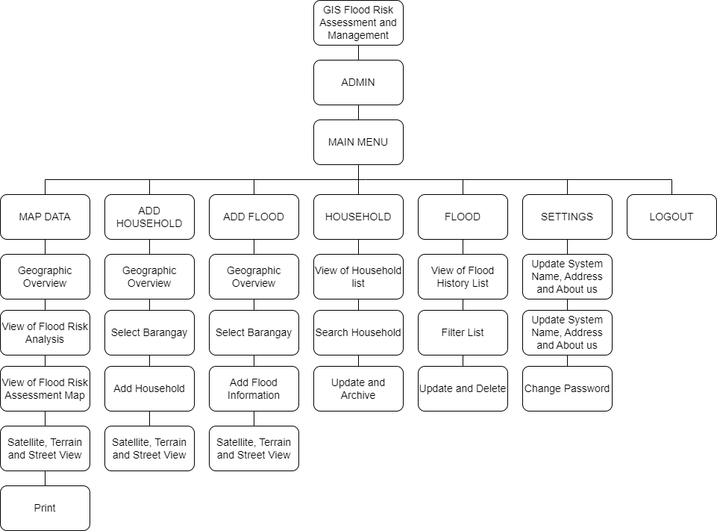

Fig. 2. Hierarchical structure of the GIS-based web application

### Project Development

In order to enhance the system, the research employed the agile system development life cycle for project creation. The subsequent are the phases implicated:

Requirements Gathering, Designing, Developing, Testing, Deployment, Review and Launch.

**Requirements.** The data necessary for developing the program was identified through collaboration with the Municipal Disaster Risk Reduction and Management Office in Paluan, Occidental Mindoro. The proponents conducted interviews with LDRRMO III Officer Albert A. Dimaano to gather the specific requirements essential for the project.

**Designing**. In designing the Geographic Information System Flood Risk Assessment Management Paluan Occidental Mindoro, the researchers used the adobe xd application for the prototype of the system of Municipality of Paluan. The hierarchical diagram visually represents the relationships between different components, layers, and functionalities within the GIS. It serves as a roadmap for users and developers, ensuring clarity and efficient navigation.

**Development.** After the Requirements and designing are finished, developing the system process can really advance. Up to this point, the project’s initial iteration had all of the planning, specification, and design documents programmed. The researchers used Visual Studio, TypeScript, and Tailwind CSS for coding and Firebase for database server to create the system.

**Evaluation and Testing**. After the implementation, all every code phase will attempt to start at this point by using various testing techniques. It identifies potential system faults that could happen. The system assessed and tested by five (5) IT expert. To ensure that the system is operating properly, they will verify its input and output.

**Deployment**. After the geographic information management system with geotagging in Paluan, Occidental Mindoro has been evaluated the system is ready to be deployed and to assist inhabitants of MDRRMO Paluan Occidental Mindoro.

**Review.** After the geographic information management system with geo-tagging in Paluan, Occidental Mindoro was deployed, the researchers reviewed the performance of the system. The review step is used to determine whether the system is functioning well or not.

**Launch.** Following a series of tests, deployment, and the proponent’s consideration of all user reviews, the web app was made available to the public and the

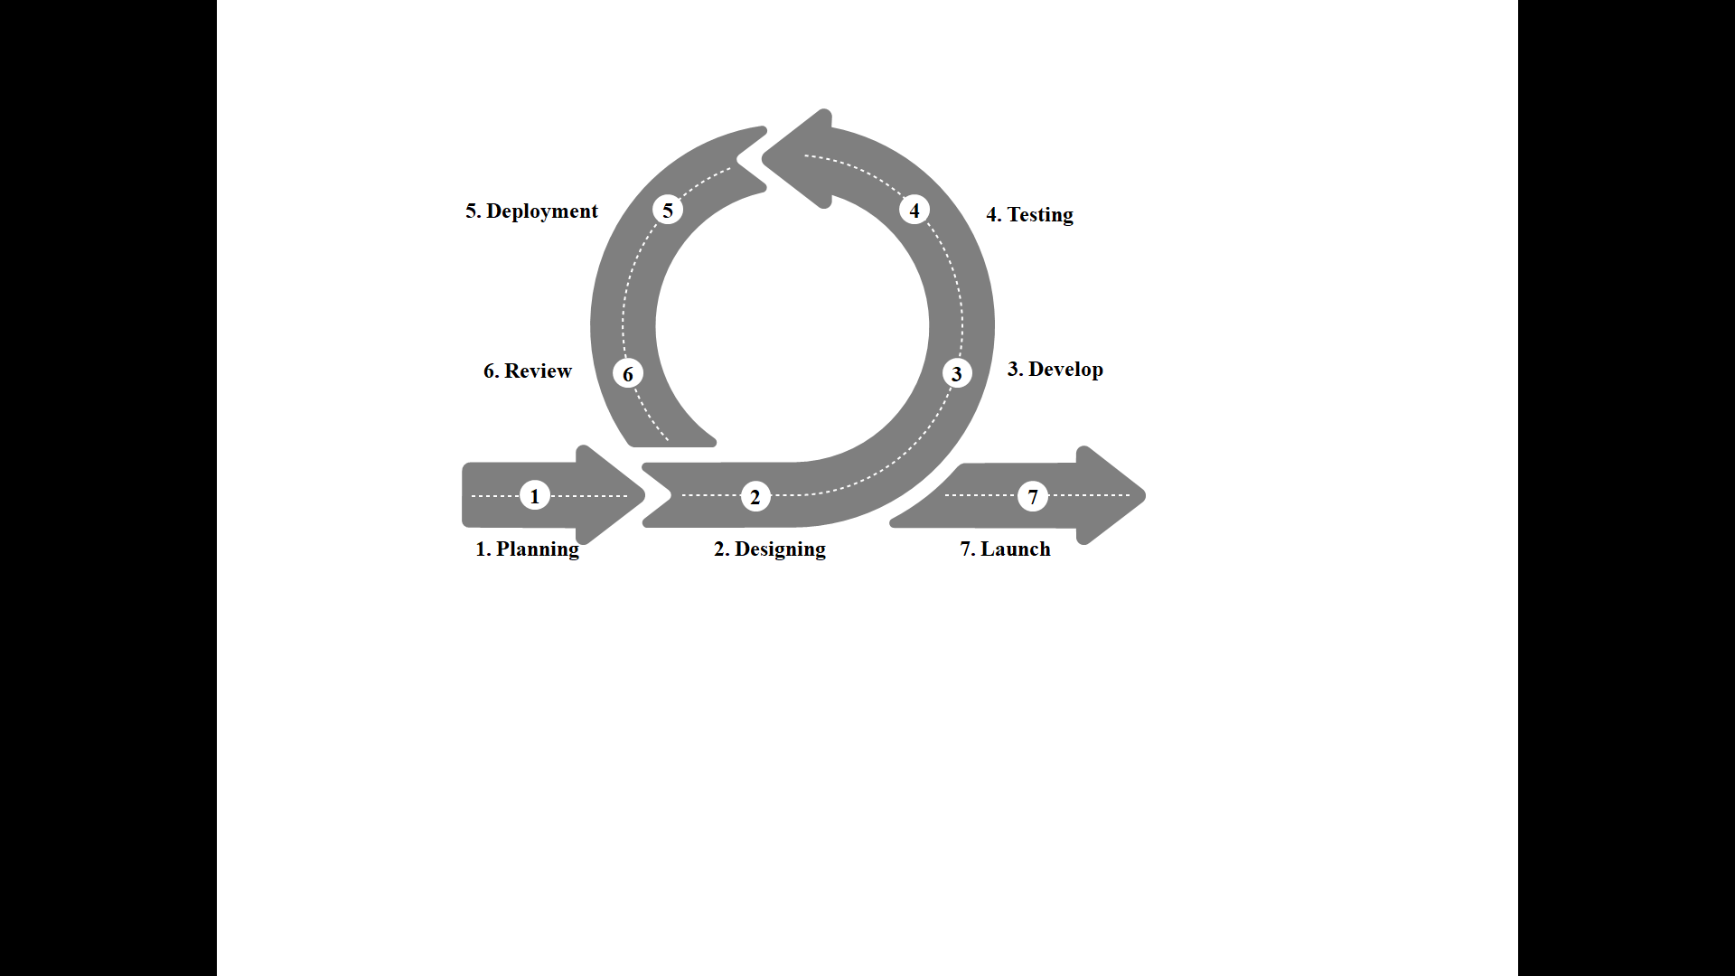target users.

Fig. 3. The Agile of development life cycle.

### Operational and Testing Procedures

The following are the operational and testing procedures of the study.

Operational procedures:

### Operational and Testing Procedures

The following are the operational and testing procedures of the study.

Operational procedures:

**Admin Account:**

1. Access the system by navigating to the “login page” and entering your administrator credentials.
2. Upon successful login, you will be directed to the “Main Menu**”** where you can access the system's various buttons, including “Map Data”, “Add Household”, “Add Flood”, “Household”, “Flood”, “Settings”, and “Logout”.
3. Navigate to the “Map Data” page by clicking on the “Map Data” button from the main menu.
4. Select the “Map” or “Satellite” button to view the satellite or terrain views of the area.
5. Drag the “Pegman” onto the map to open the street views.
6. Click on the  button to view the “Household”, “Flood history”, and “Analysis” on the map. You can use the filter to choose the barangay and the year.
7. Click on the  to access the “Flood Risk Assessment Tool” to view regions categorized by “Flood Hazard”, “Flood Risk CPF”, “Flood Risk ELU”, “Flood Risk Lifeline”. Use the map features for zooming, panning, and switching between different views.
8. Click on the “Add Household” button to navigate to the “Add Household” page.
9. Select the barangay you wish to input household data for by clicking “Select Barangay”.
10. Pinpoint the exact location of the household by clicking the map and enter new household information such as, “Household Number”, “Household Structure”, “Name of the Household Head”, “Age”, “Sex”, “Contact Number”, and “Household Members”.
11. The system will automatically integrate this data into the geographic view for spatial analysis.
12. Navigate to the “ADD FLOOD” page by clicking the “ADD FLOOD” button.
13. Select the affected barangay using the “Select Barangay” option.
14. Enter specific flood data such as “date”, “water level”, “rainfall amount”, and “cause of flood” through the “Add Flood Data” form.
15. Save the flood data, which will be updated on the system’s geographic map, allowing the administrator to visualize the impacted areas.
16. Click on the “HOUSEHOLD” button to view the list of households within the system.
17. Use the “Search Household” function to quickly locate a specific household.
18. Update or archive outdated information by selecting the “Update” and “Archive” option.
19. Click on the “FLOOD” button to view the “Flood History List”, which contains records of all flood incidents.
20. Use the “Filter List” feature to narrow down floods by “date”, “severity”, “barangay”, “severity”, “water level”, and “rainfall amount”.
21. For flood records that require adjustments, use the “Update” and “Delete” options to edit or remove flood entries as necessary.
22. Click on the “SETTINGS” button for system configuration.
23. Use the “Update System Name”, “Address”, and “About Us” to update basic system information.
24. Modify system certificates, and “change system passwords” through the respective options.
25. After completing tasks, navigate to the “LOGOUT” option in the main menu.
26. Confirm the action to securely exit the system.

**Testing Procedure**

1. Checking the functionality in different web browser.
2. Compatibility testing for computers and laptops running Windows 10 or later with at least 3GB of RAM and mobile devises running Android version 6 to 12.
3. Security testing for potential vulnerability such as SQL injection and Web Fuzzing.

**Evaluation Procedure**

The web-application will be assessed using these procedures.

1. Preliminary Assessment
   1. Preliminary evaluation of the researcher on the expected output will be conducted.
2. Project Demonstration
   1. The proponents will randomly select, one (1) supervising officer, six (6) IT experts will be invited to evaluate the system through the use of printed forms as an evaluation tool.
   2. The proponents will present the GIS-base web-application.
   3. The researchers will ask the invited respondents to operate the application and observe the performance.
3. Final Evaluation
   1. The evaluation instruments will be given among the seven (7) respondents.
   2. The researchers will ask the respondent to rate the system based on the criteria of the evaluation instrument and ask them to provide their comments, suggestions and recommendations using the five-point Likert scale presented in Table 1.

Table 1. Likert scale, descriptive rating, and range distribution.

|  |  |  |
| --- | --- | --- |
| **Scale** | **Descriptive Rating** | **Range Distribution** |
| 5 | Excellent | 4.51 - 5.00 |
| 4 | Very Good | 3.51 - 4.50 |
| 3 | Good | 2.51 – 3.50 |
| 2 | Fair | 1.51 – 2.50 |
| 1 | Poor | 1.00 – 1.50 |

**CHAPTER IV**

**RESULTS AND DISCUSSION**

The project’s description, organizational structure, capabilities, and project evaluation are all presented in this chapter.

**Project Description**

Geographic Information System for Flood Risk Assessment and Management in Paluan, Occidental Mindoro, This GIS map visually represents data, revealing previously unseen features by highlighting them and showing changes over time based on the given attributes, with added of delivering a reliable and mapping services. The web application also provides features handling of user accounts, permission, and roles efficiently in order to monitor user’s account. Moreover, web application provides a data analysis and visualization with geo tagging on adding household records. This also navigate tools such as zoom, search, and point layer, and generating reports. This innovative approach aims to improve disaster preparedness and response in Paluan, ensuring the safety and well-being of its residents.

This web application features that allows to identify the Flood Risk Assessment and Management in Paluan. This will help to control and have advance plans for flood risk in Paluan.

**Project Structure**

This section shows the GISFRAM overall user interface.

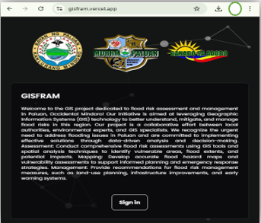Figure 4 shows the Access menu. It includes the logo of Bayan of Paluan with MDRRM and the sign in button.

Fig. 4. Access menu.

Figure 5 shows the “Sign in” page of the web-app. admin are directed to the application login page after accessing the link.

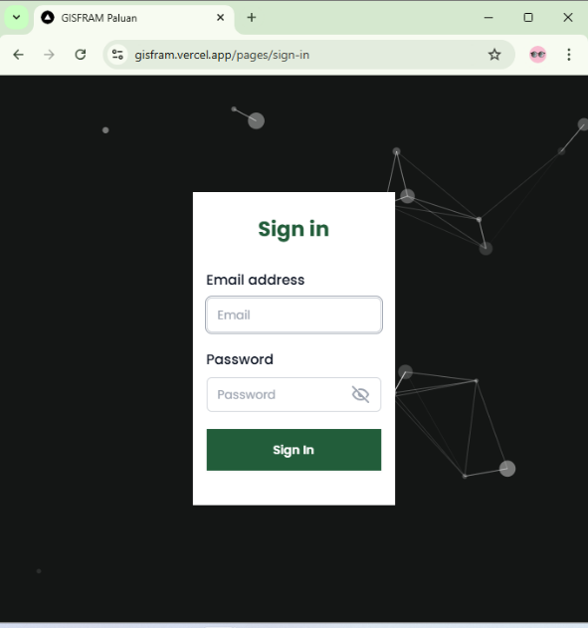

Fig. 5. Login page of the web-app.

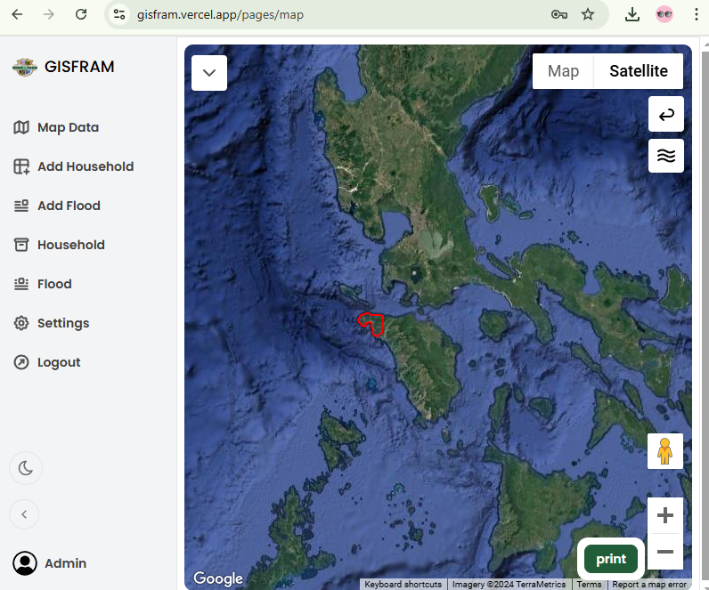Figure 6 shows the home screen. The home screen or the Map Data includes the title of the application GISFRAM at the upper left with another menu. In addition to this, the profile icon which can be the image of the admin is located at the lower-left corner of the screen to access the profile section.

Fig. 6. Home Screen.

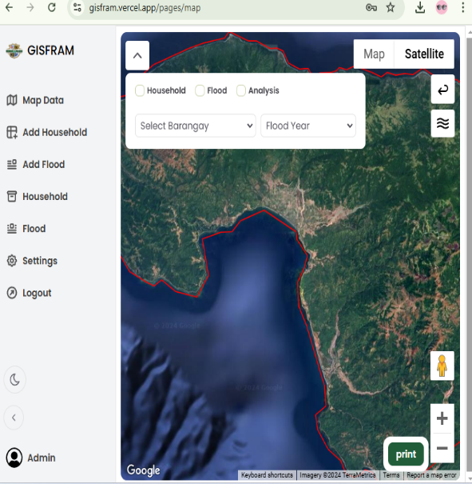 Figure 7 shows the button to view the “Household”, “Flood history”, and “Analysis” on the map. Admin can use the filter to choose the barangay and the year.

Fig. 7. the Dropdown button

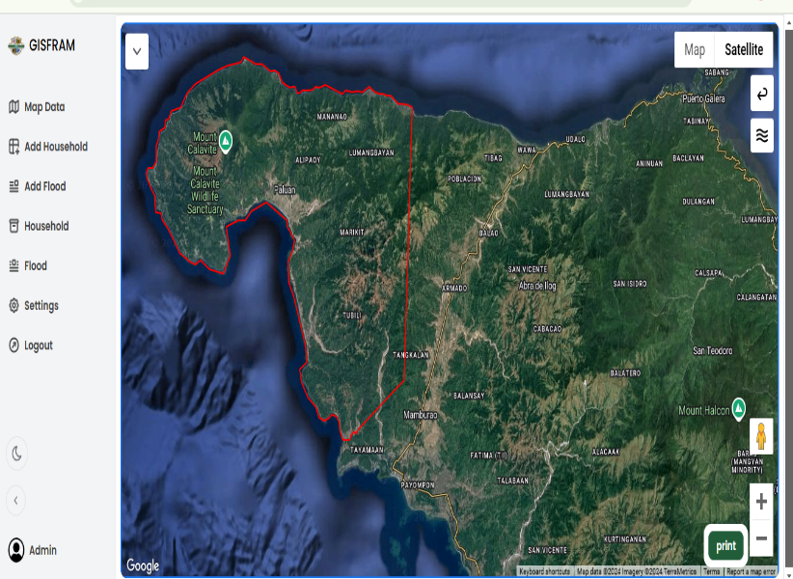Figure 8 show the satellite map with label, where in admin can click label to identify barangay in the Map.

Fig. 8. Satellite Map

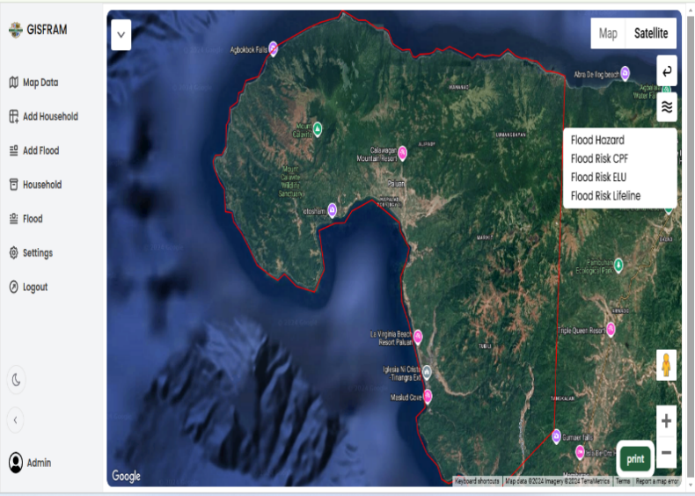Figure 9 show the  Click to access the “Flood Risk Assessment Tool” to view regions categorized by “Flood Hazard”, “Flood Risk CPF”, “Flood Risk ELU”, “Flood Risk Lifeline”. Use the map features for zooming, panning, and switching between different views.



Fig. 9. Flood Risk Assessment Tool.

Figure 10 show the “Add Household” button to navigate to the “Add Household” page.

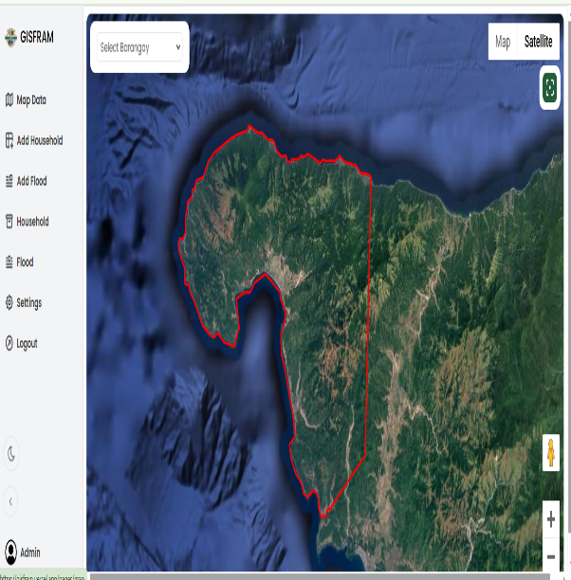

Fig. 10. Add Household

Figure 11 show “Select Barangay” to input household data Select the barangay you wish to input household data. After select barangay Pinpoint the exact location of the household by clicking the map and enter new household information such as, “Household Number”, “Household Structure”, “Name of the Household Head”, “Age”, “Sex”, “Contact Number”, and “Household Members”. The system will automatically integrate this data into the geographic view for spatial analysis.

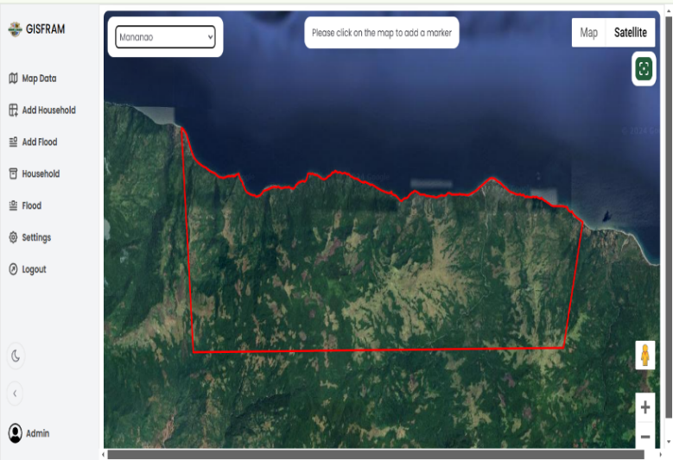

Fig. 11. Select Barangay

Figure 12 show “ADD FLOOD” Admin may Select the affected barangay using the “Select Barangay” option. Enter specific flood data such as “date”, “water level”, “rainfall amount”, and “cause of flood” through the “Add Flood Data” form. Save the flood data, which will be updated on the system’s geographic map, allowing the administrator to visualize the impacted areas.

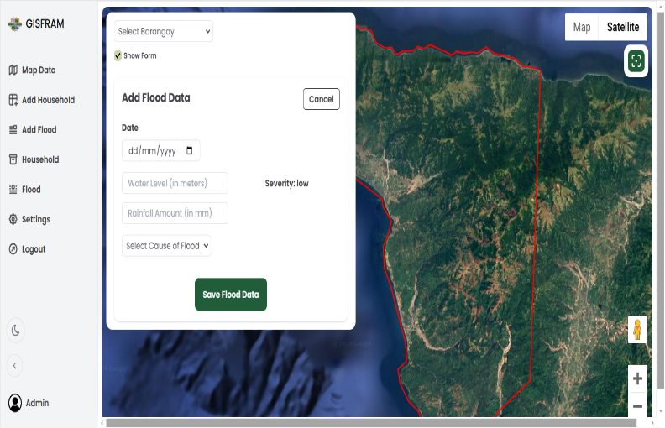

Fig. 12. Add Flood

Figure 13 show “Household” button to view the list of households within the system. Admin may Use the “Search Household” function to quickly locate a specific household. Update or archive outdated information by selecting the “Update” and “Archive” option.

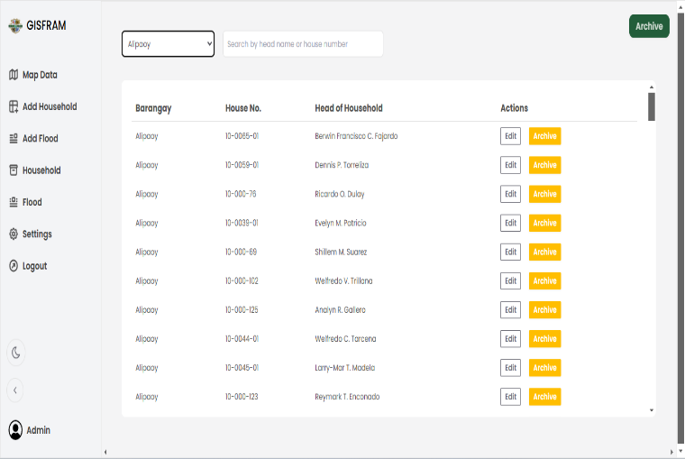

Fig. 13. Household

Figure 14 show “FLOOD” button to view the “Flood History List”, which contains records of all flood incidents. Admin can use the “Filter List” feature to narrow down floods by “date”, “severity”, “barangay”, “severity”, “water level”, and “rainfall amount”. For flood records that require adjustments, use the “Update” and “Delete” options to edit or remove flood entries as necessary.

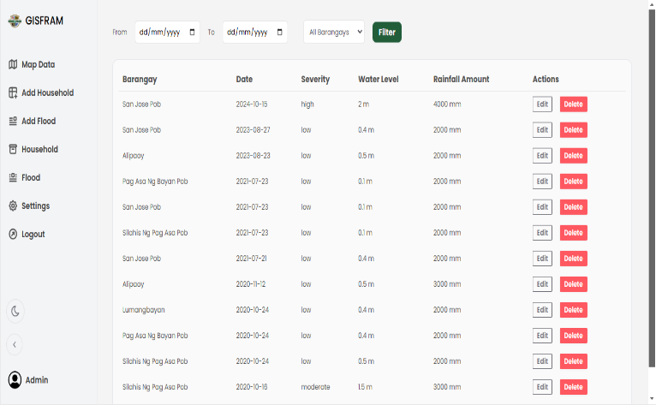

Fig. 14. Flood

Figure 15 show “SETTING” button for system configuration. Admin can use the “Update System Name”, “Address”, and “About Us” to update basic system information. Modify system certificates, and “change system passwords” through the respective options.

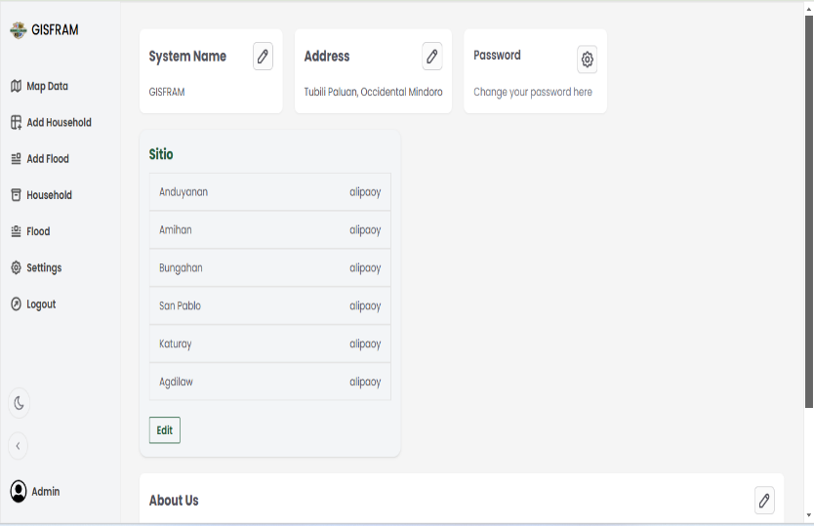

Fig. 15. Setting

**Project Capabilities and Limitations**

The system exhibits capabilities in user interaction, reliable and interactive mapping service, data analysis and visualization, adding household records. Notably, it has an generate reports and back up data using import and export. To provide features handling accounts, permissions and roles of admin efficiently.

System capabilities:

1. User interaction: Geographic Information System fosters effortless user interaction, allowing admin to navigate its features with ease.
2. To provide a map using Google Maps API
3. It has reliable and interactive mapping service.
4. It has data analysis and visualization
5. Adding household records: The system empowers admin to have adding household record
6. Generate reports and back up data using import and export: Admin can generate reports and also can have a backup using the import and export.
7. It runs on Windows 10 or later with at least 3GB of RAM and mobile devises running Android version 6 to 12.
8. It requires an internet access.

Table 2 presents the results of the testing conducted in all forms based on the capabilities of the Android version. The system worked properly on different Android versions. The outcome proves that the application complimented the Android latest version.

Project Limitations:

1. The website does not include an integrated room for a message.
2. Additionally, the website GIS facilitates communication among various stakeholders, including government agencies, NGOs, and the local community, ensuring a unified and effective response.

Based on the series of testing conducted by the researchers to identify the strengths and weaknesses of the website, the table below shows the results of the performed system testing.

Table 2. Test results.

|  |  |
| --- | --- |
| **Components** | **Findings** |
| **Operating Systems** |  |
| **Windows Version** |  |
| 1. Windows 8 2. Windows 10 3. Windows 11 4. Ios 16.7.2 | The web-application display and runs smoothly with proper responsiveness.  The web-application display and runs smoothly with proper responsiveness  The iPad and iPhone versions run smoothly with proper responsiveness. |
| 1. iOS 17.7.2 | The iPad and iPhone versions run smoothly with proper responsiveness. |
|  |  |
| **Android Version** |  |
| 1. Android 11 | The web-application runs smoothly with proper responsiveness. |
| 1. Android 12 | The web-application runs smoothly with proper responsiveness. |
| 1. Android 13 | The web-application runs smoothly with proper responsiveness. |
| 1. Android 14 | The web-application runs smoothly with proper responsiveness. |
|  |  |
| **Browser**   1. Google Chrome 2. Microsoft Edge 3. Mozilla Firefox 4. Safari | The web-application displays and runs smoothly  The web-application displays and runs smoothly  The web-application displays and runs smoothly  The web-application displays and runs smoothly |
| **Devices** |  |
| 1. Laptop/Desktop | The web-app displays all the components of the webpage. |
| 1. Mobile Phone | The web-app is responsive to different types of mobile phone screen resolutions. |

**Project Evaluation**

The effectiveness of the project was assessed across various aspects, including functionality, performance efficiency, content, compatibility, usability, and security. A total of 7 individuals, comprising of four (6) IT experts, and one (1) from the participated in the system evaluation.

To know the system’s level of performance, a series of tests and evaluations were

conducted. The study used a five-point Likert scale to interpret the evaluation results. This scaling method shows that the highest rating is five which is interpreted as “excellent” and

1 is the lowest rating which is interpreted as “Poor.” The evaluation results from the respondents are presented below:

The functionality of the application demonstrated “Very Good” performance, achieving an overall mean of 4.07. The set of functions covered all specified tasks, user objectives, and facilitated accomplishment, providing correct results with the necessary precision. This excellence extended to the overall functionality of the application.

Performance efficiency yielded “Very Good” results as well, with an overall mean of 4.28. The system’s responsiveness, processing times, and throughput rates met the established requirements, indicating efficient resource utilization during its functions.

In terms of content, the application exhibited “Very Good” performance, achieving an overall mean of 4.39. The content proved to be useful, valid, well-organized, and aligned with the objectives of the website.

The system demonstrated “Excellent” compatibility, attaining an overall mean of 4.43. It showcased compatibility with different browsers and computer components, ensuring portability and accessibility across various platforms.

Usability was rated as “Very Good”, with an overall mean of 4.14. Users found the application easy to learn, operate, and control, contributing to effectiveness, efficiency, freedom from risk, and satisfaction in a specified context of use.

While security performance was “Very Good”, with an overall mean of 4.04, the system ensured data accessibility only to authorized individuals and prevented unauthorized access or modification of computer programs or data. The actions of users within the web application could be uniquely traced, contributing to overall security.

For the system functionality suitability, the set of functions covers all the specified tasks, the user objectives, and the facilitation of the accomplishment. The system provides the correct results with the needed degree of precision. In overall, most of the functions were performed by the system and relevant to the work of the client.

Table 3 shows the functionality performance of the application in terms of correct result with needed information with an overall mean of 4.07 interpreted as “Very Good.” It shows that the applications excellently provided the necessary objectives.

Table 3. Evaluation result for functionality performance of the web-app.

|  |  |  |
| --- | --- | --- |
| **Indicators** | **Mean** | **Descriptive Rating** |
| The functions are appropriate to the specifications and its objectives. | 4.00 | Very Good |
| The web applications provide correct results with the needed degree of precision. | 4.14 | Very Good |
| **Overall Mean** | **4.07** | **Very Good** |

*Scale 1.00-1.49-Poor, 1.50-2.49-Fair, 2.50-3.49-Good, 3.50-4.49-Very Good, 4.50-5.00-Excellent*

For performance efficiency, the evaluation results present the response, processing times and throughput rates of the system when performing its functions. This indicates that the amounts and types of resources used by the system when it performed its functions met the requirements. Furthermore, the maximum limits of the system parameter were also achieved as one of the requirements. Table 4 shows the evaluation result for the performance efficiency of the application with the overall mean of 4.28 interpreted as “Very Good.” The evaluation demonstrates that the program is user-friendly and makes use of a standard user interface to facilitate user adaptation. For simple screen switching, the application provides a navigation bar.

Table 4. Evaluation result for performance efficiency of the app.

|  |  |  |
| --- | --- | --- |
| **Indicators** | **Mean** | **Descriptive Rating** |
| The response and processing times and throughput rates of system, when performing its functions, meet requirements. | 4.42 | Very Good |
| The amount and types of resources used by the system, when performing its functions, meet requirements. | 4.14 | Very Good |
| **Overall Mean** | **4.28** | **Very Good** |

*Scale 1.00-1.49-Poor, 1.50-2.49-Fair, 2.50-3.49-Good, 3.50-4.49-Very Good, 4.50-5.00-Excellent*

For content, the results shows that the system can perform its required functions efficiently and with the resources of other application without harmful impact on any other application. Table 5 shows the evaluation results of content performance of the system. The system got an overall mean of 4.39 or interpreted as “Excellent.” It shows that content is useful, valid and well organized.

Table 5. Evaluation result for content performance of the web-app.

|  |  |  |
| --- | --- | --- |
| **Indicators** | **Mean** | **Descriptive Rating** |
| The content is useful and valid. | 4.43 | Very Good |
| The objectives of website fits to the nature of organization. | 4.57 | Excellent |
| The content of the website is accessible. | 4.57 | Excellent |
| The content is well-organized. | 4.00 | Very Good |
| **Overall Mean** | **4.39** | **Very Good** |

*Scale 1.00-1.49-Poor, 1.50-2.49-Fair, 2.50-3.49-Good, 3.50-4.49-Very Good, 4.50-5.00-Excellent*

For compatibility, the results shows that the system can perform its required functions efficiently and with the resources of other products without harmful impact on any other products. Table 6 shows the evaluation results of content performance of the system. The system got an overall mean of 4.43 or interpreted as “Excellent.” This demonstrates the web application’s portability and ensures its accessibility to a wide range of users.

Table 6. Evaluation result for compatibility performance of the web-app.

|  |  |  |
| --- | --- | --- |
| **Indicators** | **Mean** | **Descriptive Rating** |
| The specification of the web application is compatible to different browsers and other computer components. | 4.43 | Very Good |
| The specification of the web application is compatible to different browsers and other computer components | 4.43 | Very Good |
| **Overall Mean** | **4.43** | **Very Good** |

*Scale 1.00-1.49-Poor, 1.50-2.49-Fair, 2.50-3.49-Good, 3.50-4.49-Very Good, 4.50-5.00-Excellent*

For the usability, the result shows that the users can recognize whether a product or system is appropriate for users’ needs because the system is easy to use and learnable. The system can be used by specified users to achieve its goals to meet the requirements of effectiveness, efficiency, freedom from risk and satisfaction in a specified context of use. This is composed of attributes that make the system easy to operate and control. The system also protects the users from encountering errors or mistakes. The user interface enables pleasing and satisfying interactions with the user and this can also be used in the widest range of characteristics and capabilities to achieve the specific goals of the system. Table 7 shows the usability performance of the application with the overall mean of 4.14 interpreted as “Excellent.” According to the evaluation, the program is user-friendly and makes use of a standard user interface to make it simple for users to become used to it.

Table 7. Evaluation result for usability performance of the web-app.

|  |  |  |
| --- | --- | --- |
| **Indicators** | **Mean** | **Descriptive Rating** |
| The users can learn how to use the web application easily for effectiveness, efficiency, freedom from the risk and satisfaction in a specified context of use. | 4.43 | Very Good |
| The web application has attributes that make it easy to operate and control. | 4.14 | Very Good |
| The web application protects the user against making errors. | 3.86 | Very Good |
| The user interface enables pleasing and satisfying interaction for the user. | 4.14 | Very Good |
| **Overall Mean** | **4.14** | **Very Good** |

*Scale 1.00-1.49-Poor, 1.50-2.49-Fair, 2.50-3.49-Good, 3.50-4.49-Very Good, 4.50-5.00-Excellent*

For the security, the system achieved the level of satisfaction of the clients in terms of data security and confidentiality. It shows that data are accessible only by those authorized and prevents unauthorized access for system protection. The system also provides audit so that access to the users could be monitored and verified, also, for security purpose. Table 9 shows the security performance of the application with an overall mean of 4.04 interpreted as “Very Good.” It shows that the application ensures that the data are accessible only for those authorized to have access and it also have a backup and import data.

Table 9. Evaluation result for security performance of the web-app.

|  |  |  |
| --- | --- | --- |
| **Indicators** | **Mean** | **Descriptive Rating** |
| The web applications ensure the data are accessible only to those authorized to have access. | 3.28 | Very Good |
| The web application prevents unauthorized access to, or modification of computer programs or data. | 4.57 | Excellent |
| The actions of user in the web application can be traced uniquely. | 4.28 | Good |
| **Overall Mean** | **4.04** | **Very Good** |

*Scale 1.00-1.49-Poor, 1.50-2.49-Fair, 2.50-3.49-Good, 3.50-4.49-Very Good, 4.50-5.00-Excellent*

Table 10 presents the summary of the overall performance and evaluation results for all the criterion used in for the evaluation of the system, as functionality, performance efficiency, content, compatibility, usability, and security are all received an “Very Good” rating, reflecting high effectiveness and user satisfaction. Although security is rated as “Very Good,” slightly lower than “Excellent,” it indicates a need for enhancement to the system’s reliability.

Overall, the table highlights the system’s strong design and capacity to meet user requirements, while also suggesting avenues for refining security measures to ensure comprehensive performance across all aspects.

Table 10. Summary of evaluation results.

|  |  |  |
| --- | --- | --- |
| **Indicators** | **Mean** | **Descriptive Rating** |
| Functionality | 4.07 | Very Good |
| Performance Efficiency | 4.28 | Very Good |
| Content | 4.39 | Very Good |
| Compatibility | 4.43 | Very Good |
| Usability | 4.14 | Very Good |
| Security | 4.07 | Very Good |
| **Grand Mean** | **4.23** | **Very Good** |

*Scale 1.00-1.49-Poor, 1.50-2.49-Fair, 2.50-3.49-Good, 3.50-4.49-Very Good, 4.50-5.00-Excellent*

**Modification of the System**

After the evaluation of the system, the respondents of the study left some valuable comments and suggestions for further improvement of the system. With all the collected suggestions and recommendations, the following are the actual modifications performed in the system:

1. Improve the user-interface and make it more responsive.
2. Add data if possible
3. Make other functions work.
4. Improve record filter functions
5. Add token of expiration for every user.
6. Enhance the security.

**CHAPTER V**

**CONCLUSIONS AND RECOMMENDATIONS**

This chapter presents the summary of findings, conclusions and recommendations based on the result of the evaluation.

**Summary of Findings**

According to the final evaluation results, the following are the findings of the study:

1. Through its user-friendly design, the GISFRAM web-app efficiently facilitated and simplified the process of establishing and maintaining floods, guaranteeing an effortless admin experience.
2. The GISFRAM web-app was a user-friendly web-application with an intuitive design that contributed to easy navigation and accessibility.
3. The web application proved to be compatible with a variety of devices and browsers. The application remained responsive and functioning whether accessed from a desktop computer or a mobile device.
4. GISFRAM system also provides audit so that access to the users could be monitored and verified, also, for security purpose.
5. GISFRAM system evaluation results present the response, processing times and throughput rates of the system when performing its functions.
6. The GISFRAM system web-app has proper security measures to safeguard the users’ information.
7. The system's response, processing times, and throughput rates during operation are displayed in the evaluation results.

**Conclusions**

The study's objectives, testing results, and evaluation findings have been taken into consideration for developing the following conclusions:

1. The following functionalities are present in the successfully created GISFRAM application:
   1. To provided a map using Google Maps API
   2. System delivered a reliable and interactive mapping service.
   3. System designed a GUI and provide a user-friendly system for admin
   4. System provided user management
   5. System provided features handling user accounts, permissions, and roles efficiently.
   6. System provided data analysis and visualization; in floods and risk reduction management
   7. System provided geo-tagging on adding household records; is applied to associate specific geographic coordinates with various data points in the system.
   8. System provided navigation tools such as zoom, search, and point layer;
   9. System provided backup data using import/export.
2. The applications listed below were used to successfully create the application:
3. TypeScript, Tailwind CSS, and NextJS;
4. Firebase Database;
5. Node and NPM;

**Recommendations**

The researchers suggest the following recommendations to further improve the application’s features:

1. Add other disaster like Earthquake, Tsunami, and Landslide.
2. Add a real time detection if disaster occurred in which way is free.

**References**

Adewumi, A., Misra, S., Omoregbe, N., Crawford, B., & Soto, R. (2016). A systematic literature review of open source software quality assessment models. *SpringerPlus*, *5*(1). <https://doi.org/10.1186/s40064-016-3612-4>

Akanbi, A. K., & Agunbiade, O. Y. (2013, November 30). *Integration of a city GIS data with Google Map API and Google Earth API for a web based 3D Geospatial Application*. arXiv.org. https://arxiv.org/abs/1312.0130

Azizi, S., Ilderomi, A. R., & Noori, H. (2021). Investigating the effects of land use change on flood hydrograph using HEC-HMS hydrologic model (case study: Ekbatan Dam). *Natural Hazards*, *109*(1), 145–160. <https://doi.org/10.1007/s11069-021-04830-6>

Boulos, M. N. K. (2005). Web GIS in practice III: creating a simple interactive map of England’s Strategic Health Authorities using Google Maps API, Google Earth KML, and MSN Virtual Earth Map Control. *International Journal of Health Geographics*, *4*(1). <https://doi.org/10.1186/1476-072x-4-22>

Chakraborty S, Biswas S (2021) Simulation of flow at an ungauged river site based on

HEC-HMS model for a mountainous river basin. Arab Geosci.

[https://doi.org/10.1007/s12517-021-08385-5. 14:2080](https://doi.org/10.1007/s12517-021-08385-5.%2014:2080)

Chow, T. E. (2008). The Potential of Maps APIs for Internet GIS Applications. *Transactions in GIS*, *12*(2), 179–191. <https://doi.org/10.1111/j.1467-9671.2008.01094.x>

Flood Risk Reduction Effect by Virtual Land Mounding at Each Site in a Study Area. Journal of Water Resource and Protection, 10(10), 1160.Journal of Geographic Information Systems, 12(3), 211-225. <https://doi.org/10.1111/jfr3.12714>

Gigović, L., Pamučar, D., Bajić, Z., & Drobnjak, S. (2017). Application of GIS-Interval Rough AHP Methodology for Flood Hazard Mapping in Urban Areas. *Water*, *9*(6), 360. <https://doi.org/10.3390/w9060360>

In H. Mynett & J. Chindanai (Eds.), Flood Risk Assessment, Management and Mitigation (pp. 41-57). <https://doi.org/10.1007/978-90-481-9917-4>

Kawada, K. (2018). Flood Discharge Estimation for Un-gaugedBasins. <https://doi.org/10.3906/muh-0908-1>

Kouziokas, G. N. (2016). Geospatial based information system development in public administration for sustainable development and planning in urban environment. European Journal of Sustainable Development, 5(4), 347-347.

Lang, M., Barriendos, M., Llasat, M. C., Francés, F., Ouarda, T., Thorndycraft, V., Enzel, Y., Bardossy, A., Coeur, D., & Bobée, B. (2004). Use of systematic, palaeoflood and historical data for the improvement of flood risk estimation. Review of scientific methods. *Natural Hazards*, *31*(3), 623–643. <https://doi.org/10.1023/b:nhaz.0000024895.48463.eb>

M. L. N. Gacu (Ed.),Flood Risk Assessment Using GIS-Based Analytical Hierarchy Process. (2022). Flood Disaster Risk Assessment and Preparedness: Case Studies from the Philippines (pp. Gacu)<https://doi.org/10.3390/app12199456>

Mohammed, M. P. (2018). Disaster Risk Reduction and Management of Tarlac City. Procedia Engineering, 212, 77–84. <https://doi.org/10.1016/j.proeng.2018.01.011>

Monjardin, D. (2020). Flood Risk Analysis and Mapping through GIS-Based Analytical Hierarchy Process: A Case Study in San Andres, Catanduanes, Philippines. Journal of Geographic Information System, 12(2), 109. <https://doi.org/10.3390/app12199456>

Reddy, K. S. (2018). Geospatial technologies for sustainable land resource management. Journal of Geography and Natural Disasters, 8(1), 1–15. <https://doi.org/10.4172/2152601X.1000187>

Rincón, A., Sáez, A., García, J., & Luna, E. (2018). Flood risk analysis in urban and coastal areas using AHP and GIS. Sustainability, 10(12), 4662.DOI:10.3390/GEOSCIENCES8080275

Schumann, A. H. (2011b). Flood Risk Assessment and Management. In Springer eBooks. <https://doi.org/10.1007/978-90-481-9917-4>

Schoch, S., & Hinden, D. (2018). Software product quality: Evaluating the ISO 25010 standard. Journal of Systems and Software, 143, 224-233. <https://doi.org/10.1016/j.jss.2018.03.053>

Tanaka, A., Tachikawa, T., Ichikawa, Y., & Yorozu, S. (2016). Improvement of a Synthesis Probability Method for Estimating the Probability Function of the Annual Maximum Flood Discharge. Journal of Disaster Research, 11(4), 608-615. <https://doi.org/10.1007/s11069-021-04830-6>

Vacca, G., Fiorino, D., & Pili, D. (2018). A Spatial Information System (SIS) for the Architectural and Cultural Heritage of Sardinia (Italy). *ISPRS International Journal of Geo-Information*, *7*(2), 49. <https://doi.org/10.3390/ijgi7020049>